Press Release: For Immediate Release

**The Perfect CRM for Your Non-Profit Organization**

Running a non-profit organization is hard work, but the stress of monitoring supporters, finances, and campaigns does not have to be overwhelming. Your non-profit organization could use a CRM, or Customer Resource Management system to alleviate the workload so you can focus on your cause.

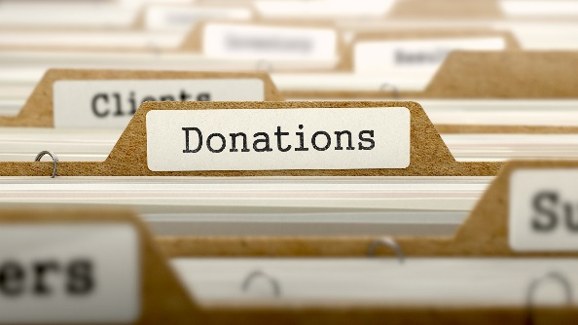

However, it is important to select a CRM system that best meets your non-profit’s needs. Here is why the eZnet CRM system is perfect for your goals:

**You Can Make It Your Own**

While many other CRM systems have fixed logos or systems they expect you to work around, the eZnet CRM system allows you to customize the product to fit the needs of your organization. With nearly seamless integration with your own methods, you can minimize the learning curve and maximize the leads you receive from crucial social media sites like Facebook, Twitter, and Instagram.

**Get Reliable and Professional Support**

When you choose the eZnet CRM system, you will have access to around-the-clock technical support. With the versatility of offering support via phone call, chat, or ticket, you can receive competent, knowledgeable, and experienced support whenever and wherever you need it.



**Never Worry About Losing Your Data**

The specialists at eZnet CRM systems ensure that you will never lose your data due to overnight power outages or accidental shutdowns. They offer a nightly backup of all data onto their secure and comprehensive cloud networks; and, unlike many other competitors that offer similar services, you do not have to pay extra for this backup feature. You read that right; you can have your data backed up onto the cloud network on a nightly basis, completely free.

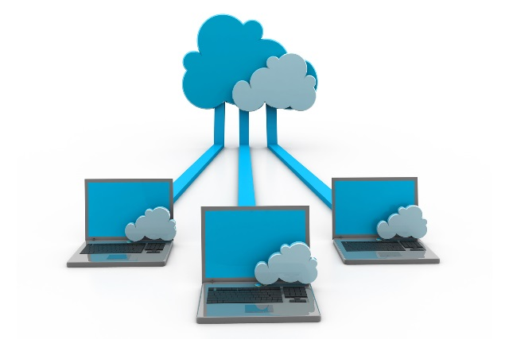

Contact information: